Insertion sort is the algorithm of choice either when the data is nearly sorted or when the problem size is small.

**Insertion Sort** is an efficient**algorithm** for sorting a small number of elements. It is similar to sort a hand of playing cards.[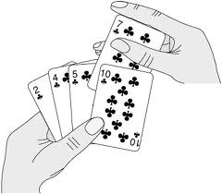](http://freefeast.info/general-it-articles/insertion-sort-pseudo-code-of-insertion-sort-insertion-sort-in-data-structure/attachment/insertion-sort-playing-cards/)

**Playing a card** is one of the techniques of sorting and in Insertion Sort we follow following steps.

– Start with an empty left hand and cards face down on the table.

– Then remove one card at a time from the table and Insert it into the correct position in the left hand.

– To find a correct position for a card, we compare it with each of the cards already in the hand from right to left.

